**DAILY ONLINE ACTIVITIES SUMMARY**

|  |  |  |  |  |  |  |  |  |
| --- | --- | --- | --- | --- | --- | --- | --- | --- |
| **Date:** | **30-05-2020** | | | | | **Name:** | **Dhanya Bhat** | |
| **Sem & Sec** | **7 B SEC** | | | | | **USN:** | **4AL16CS132** | |
| **Online Test Summary** | | | | | | | | |
| **Subject** | | **No test** | | | | | | |
| **Max. Marks** | | **-** | | **Score** | | | **-** | |
| **Certification Course Summary** | | | | | | | | |
| **Course** | **Introduction to ethical hacking** | | | | | | | |
| **Certificate Provider** | | | **Great learning** | | **Duration** | | | **6hrs** |
| **Coding Challenges** | | | | | | | | |
| **Problem Statement:**   1. Write a java program to Count number of trailing zeros in product of array. 2. Python program to read a number and print the pattern. | | | | | | | | |
| **Status: YES, Completed all Programs** | | | | | | | | |
| **Uploaded the report in Github** | | | | | **YES** | | | |
| **If yes Repository name** | | | | | https://github.com/alvas-education-foundation/Goutham-dotcom | | | |

Online Test Details: (Attach the snapshot and briefly write the report for the same)

No test

Certification Course Details: (Attach the snapshot and briefly write the report for the same)

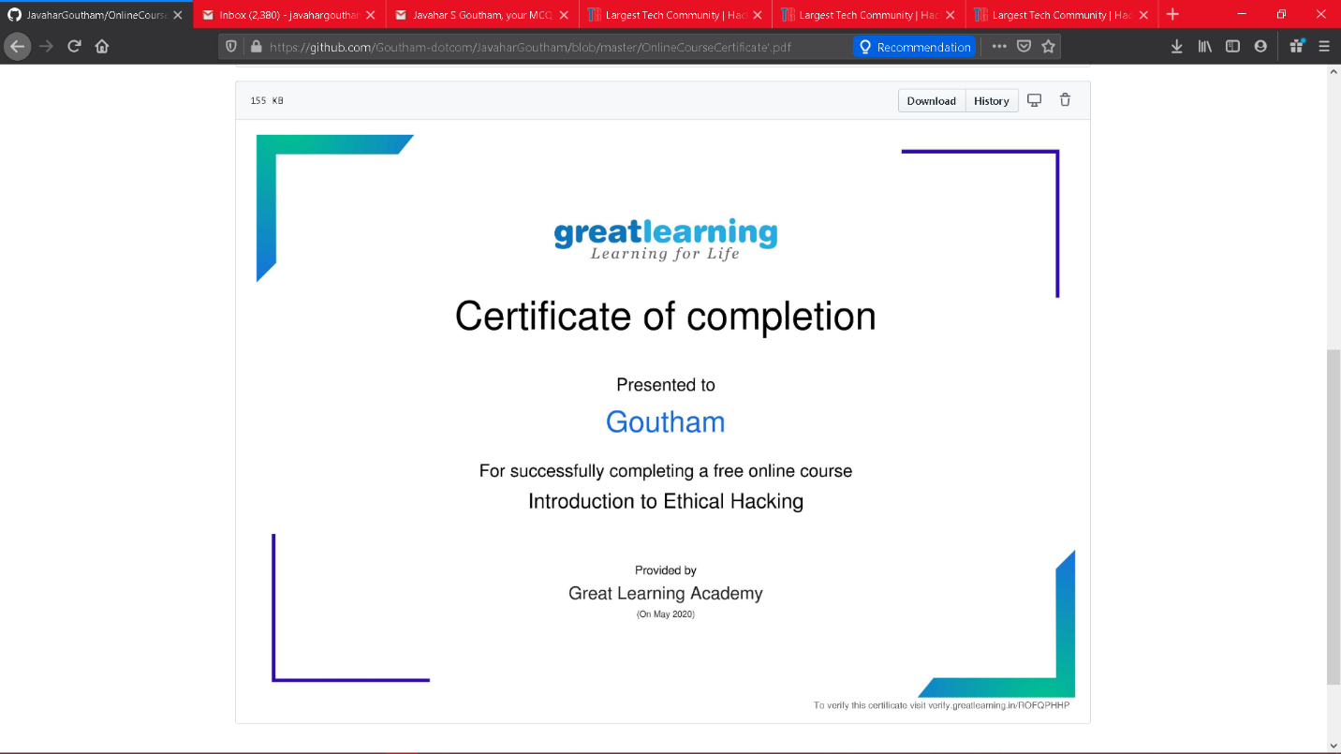

Coding Challenges Details: (Attach the snapshot and briefly write the report for the same)

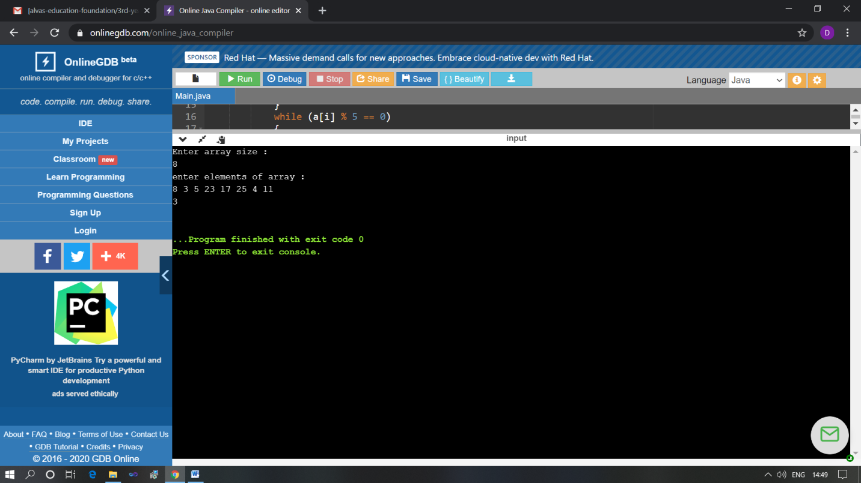

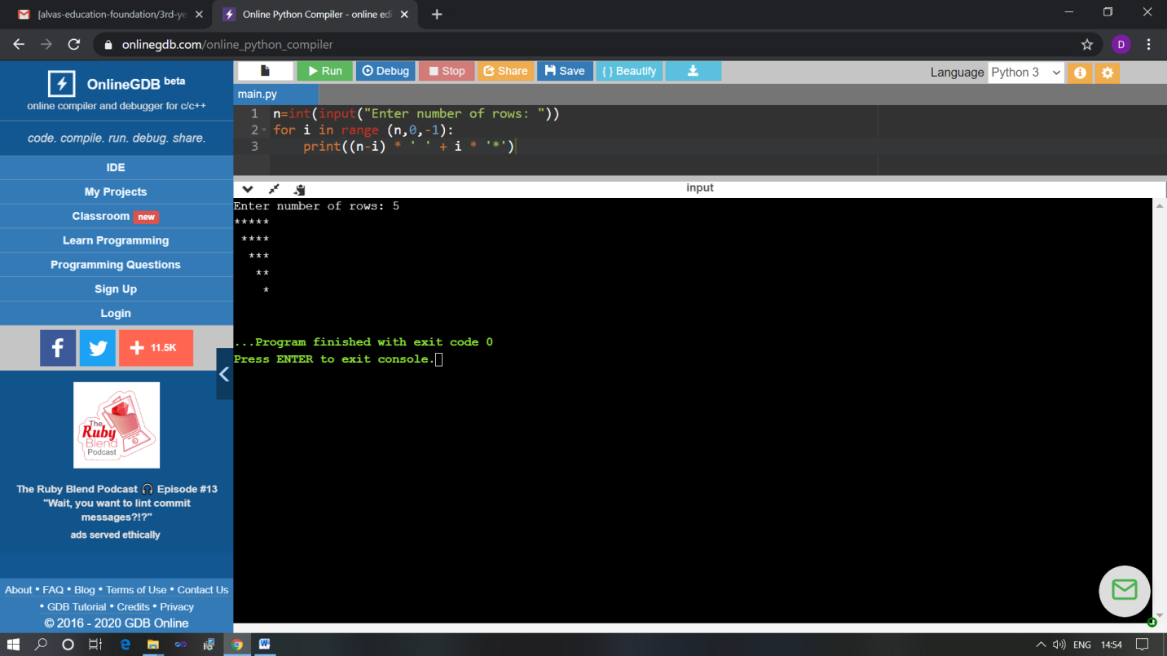

The above Programs were written and executed and the output of the same is displayed above. The code for those 2 programs have been uploaded to the github repository and the link to the same is provided on the form.